
PUBLIC

Understand the impact of triggers
  - Using trigger simulation option of Software update manager.
Version: 1.0
Date: 2026-08-26
Owner: Ananth Pai

Objective
This exercise is to show you the behavior of the system when the triggers are switched on. Also use the trigger simulation tool to generate the triggers and play with these triggers options (activating/deactivating) to identify the business impact on system.
We will be using the SFLIGHT transactions to simulate real life business scenarios.
BC_GLOBAL_SCUST_CREA – Transaction to create customer
BC_GLOBAL_SBOOK_CREA – Transaction to create a flight booking
BC_GLOBAL_SBOOK_DISP – transaction to display flight booking
Pre-requisites: PUTTB_SHD.ZIP file from a completed SAP S/4HANA conversion.
Due to the interest of time, we have completed the first few steps and currently the SUM tool is in the Activate trigger phase. We will continue from this point onwards.

1 | Launch the SUM tool | URL :  https://<IP shared in the exercise sheet>:1129/lmsl/sumabap/ABA/slui  You will be asked to login. Enter the below username and the password shared in the sheet.  User : abaadm  Password : Pa$$word2026  You may get the below security warning, select continue to …  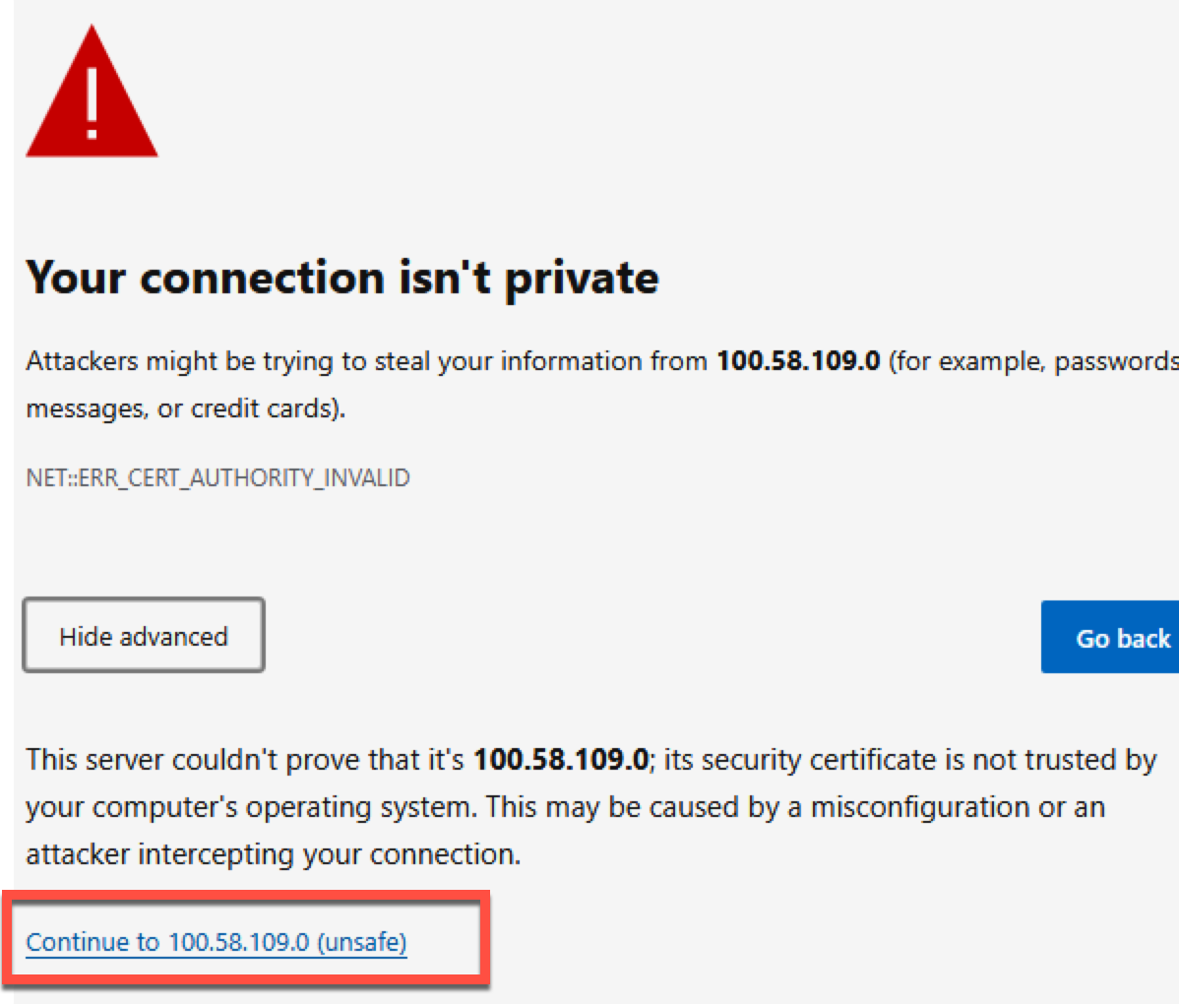
2 | The SUM tool creates the triggers on the table based on the table classification in the PUTTB_SHD.ZIP file.  The tool waits before each step of the trigger process.  At this screen the triggers on the tables are already created but are not activated. Once you click next the triggers will be activated on all the tables. | 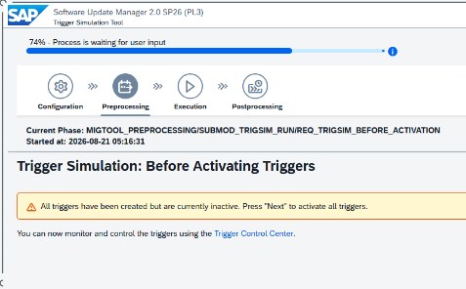  Click Next 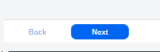
3 | Switch to the Trigger control center.  Software update manager tool -> SUM utilities -> Process control center -> Trigger control center | 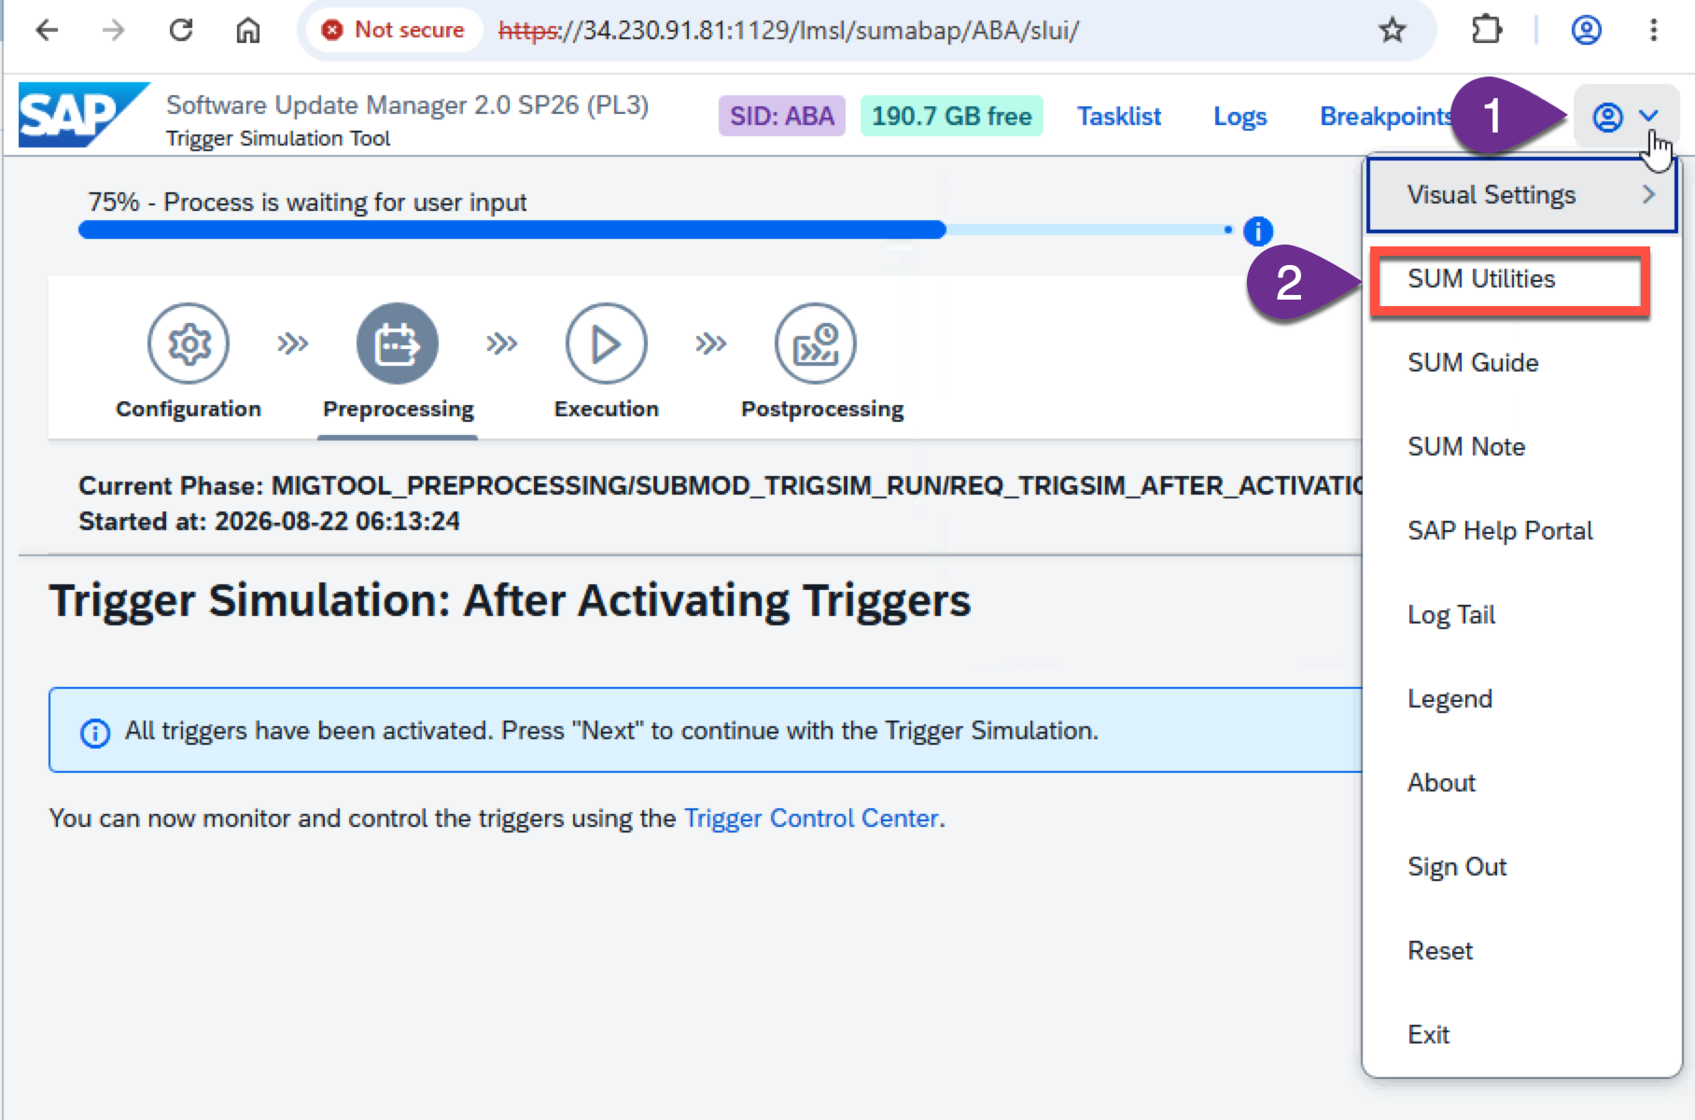  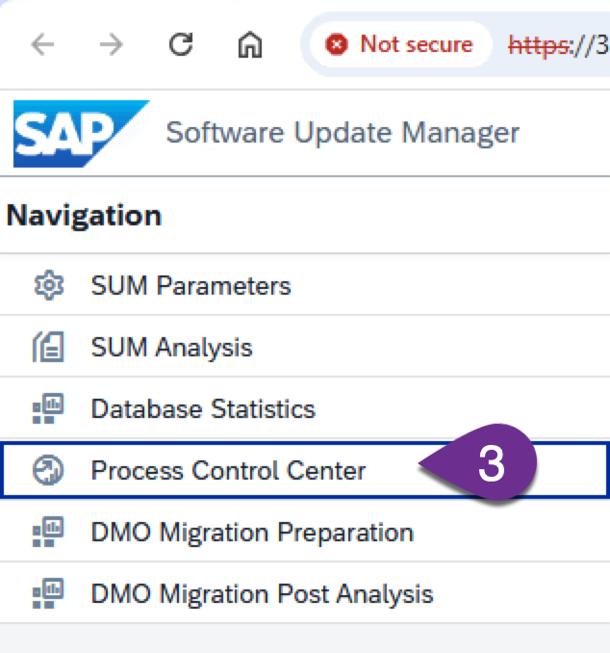  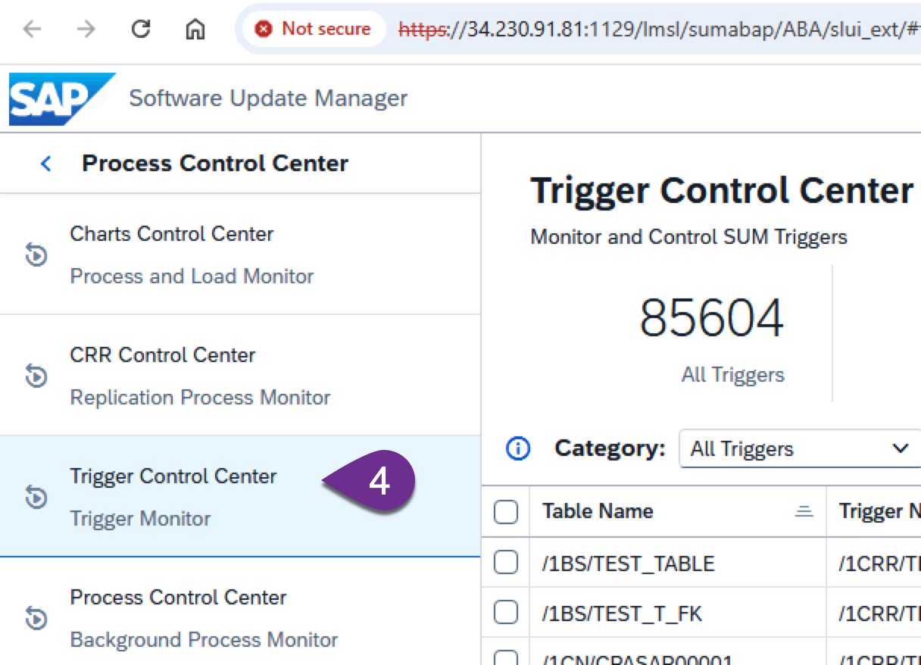
4 | Filter the table SBOOK to check the FREEZE type and status | 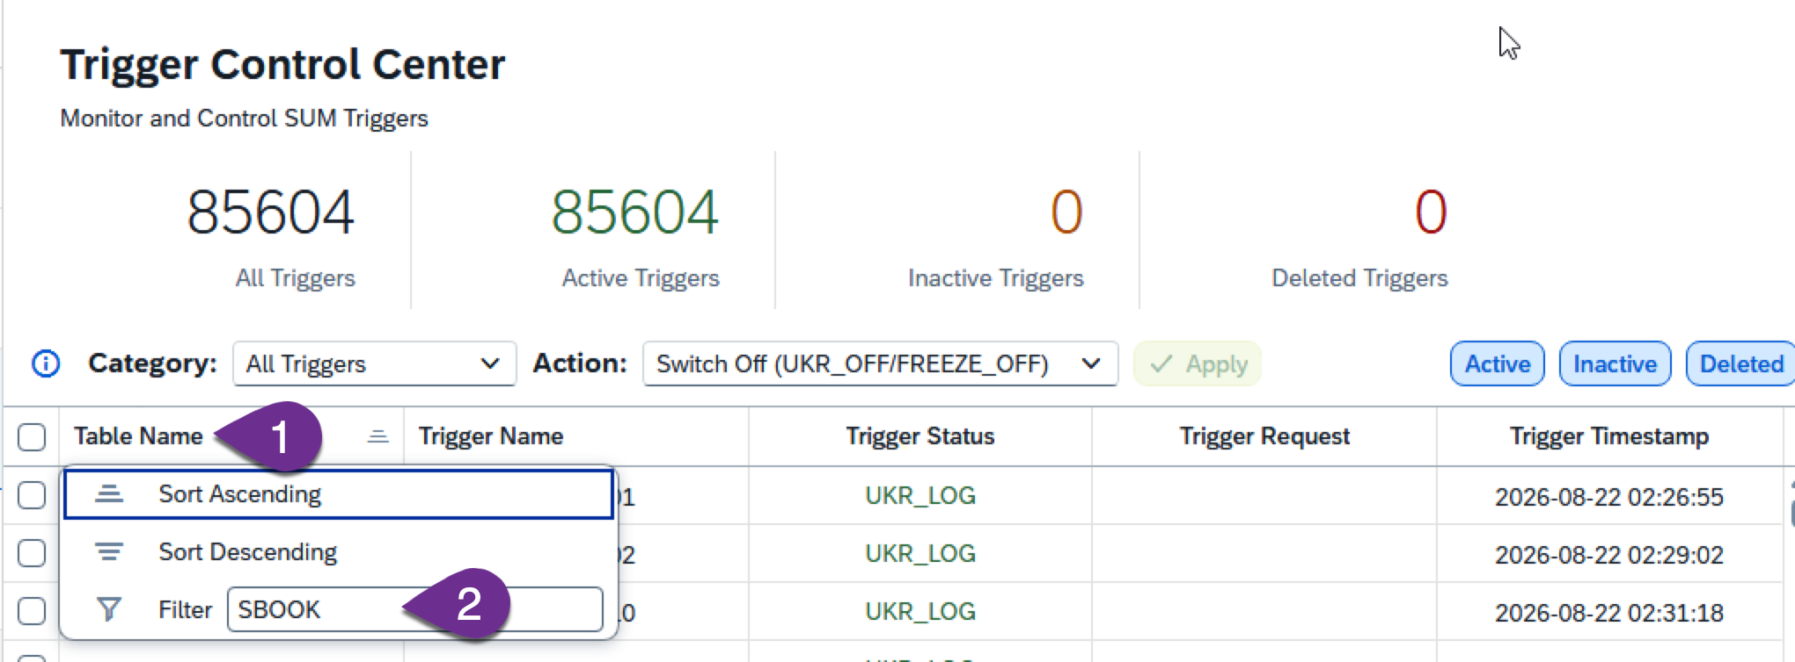  Output  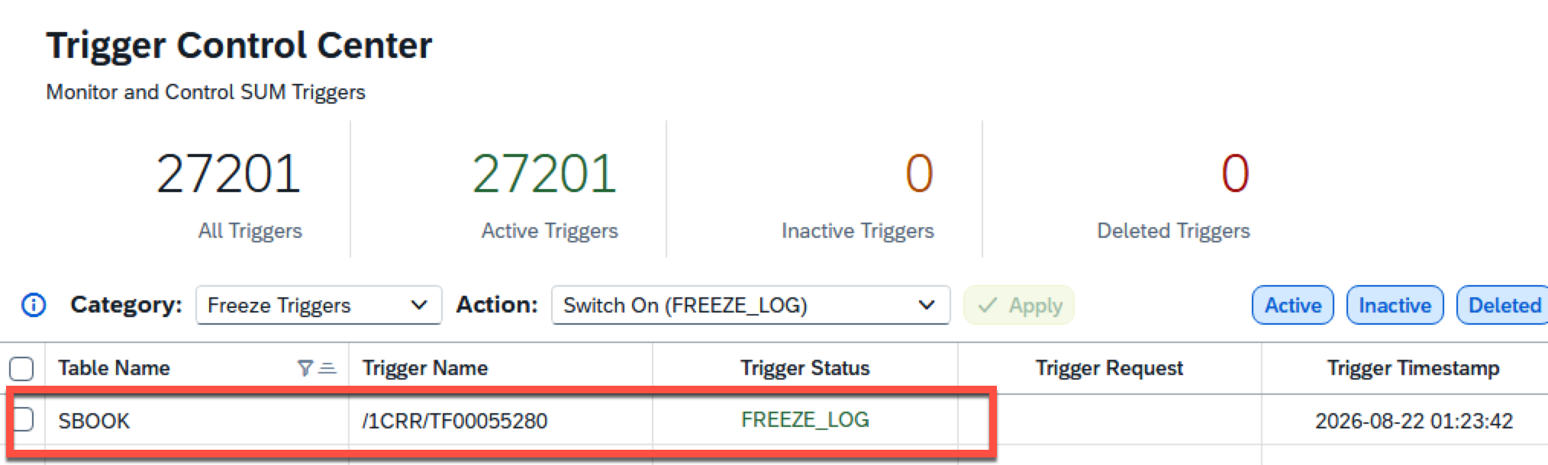  Its in the freeze_log mode, where in there will be no impact to the end user but the access will be recorded in the UPGILLACCESS table. Note that this table is not active in the dictionary, and you will have to use the DB tools to check the table.
5 | Checking if there are any access the tables which are in FREEZE mode. | If you keep the triggers active for some time (this would depend on your system and project, it can be few hours, few days or about a week. You can even target for the time that you anticipate to have freeze in the production cut over week.) , at the end of the recording, you can check the table UPGILLACCESS table to identify which tables were accessed and which have a FREEZE due to doC  Initial state  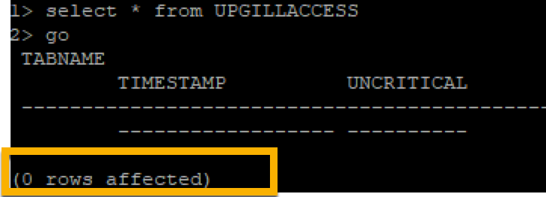  After we use the bc_global_sbook_crea transaction to book a flight ticket. 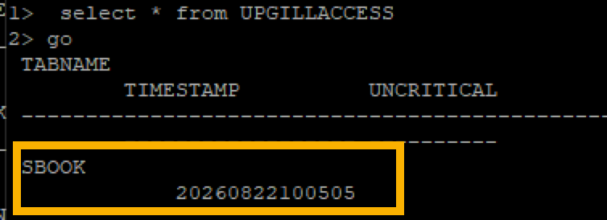
6 | Changing the Trigger modes. WE are going to change the trigger mode from FREEZE_LOG to FREEZE_LOG_ERROR | FREEZE_LOG – the access to the table will be logged in the UPGILLACCESS table, but DML statements will not be blocked  FREEZE_ERROR – the access to the table will be blocked straightaway. This would be the impact in the production business process.  FREEZE_LOG_ERROR – The access to the table will be blocked, and the access will also be logged in the UPGILLACCESS table.  Note: only the first instance of DML access will be logged.  Filter the category to Freeze triggers and also filter the table name SBOOK  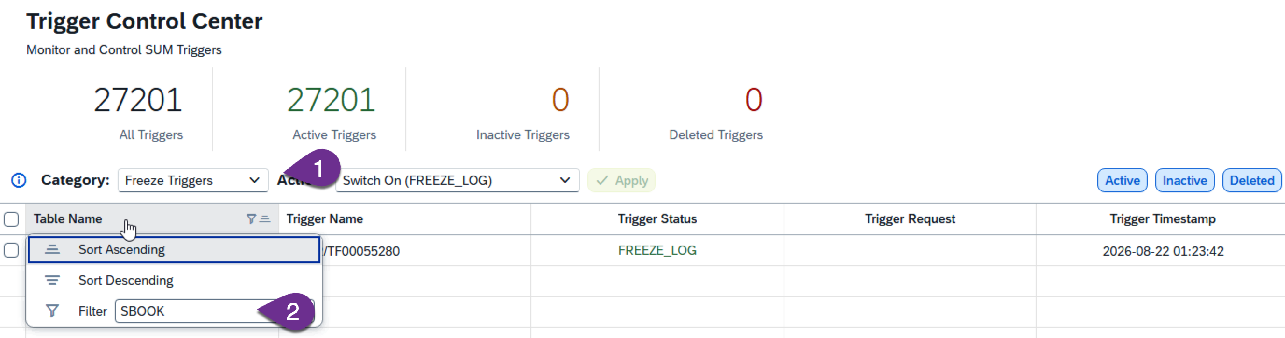  You would get something like below.  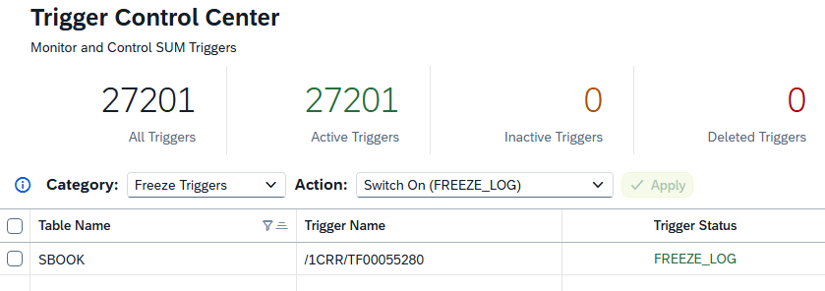  Select the table SBOOK and click on the Action filter, select the FREEZE_LOG_ERROR and select apply button. The trigger mode would change from FREEZE_LOG to FREEZE_LOG_ERROR  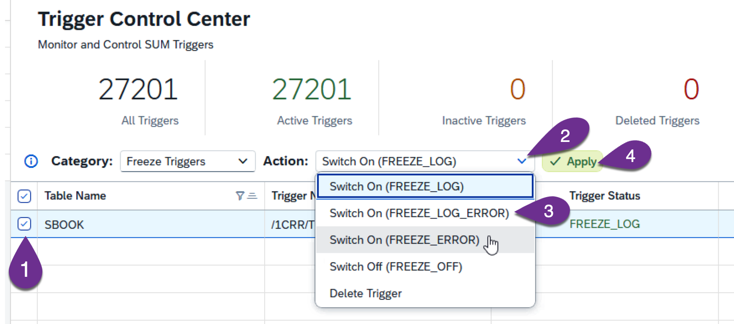  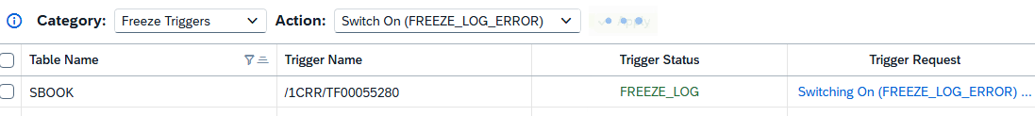
7 | Seeing the impact of the changes done | Open the transaction BC_GLOBAL_SBOOK_CREA  This transaction is to create a flight booking for a customer. I have selected the below values, but you can select the values by using the F4 option. The idea is to show you how the transaction behaves with FREEZE triggers.  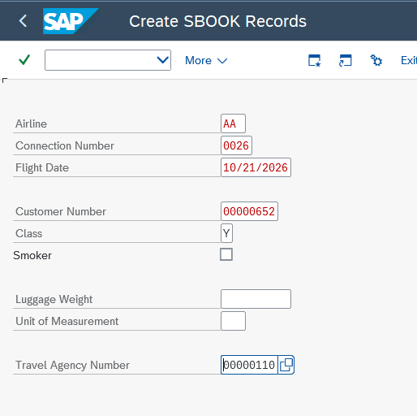  Click the save button or select the Save option as shown below  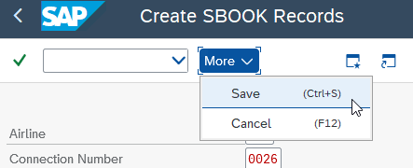  You will get a confirmation statement with the below text  But immediately you would get a failure notification as below.  Keep the booking number for your reference, to be used below.  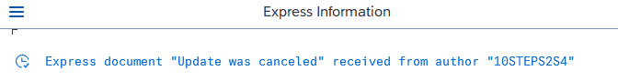  If you go to the inbox, you would see the Freeze related error.  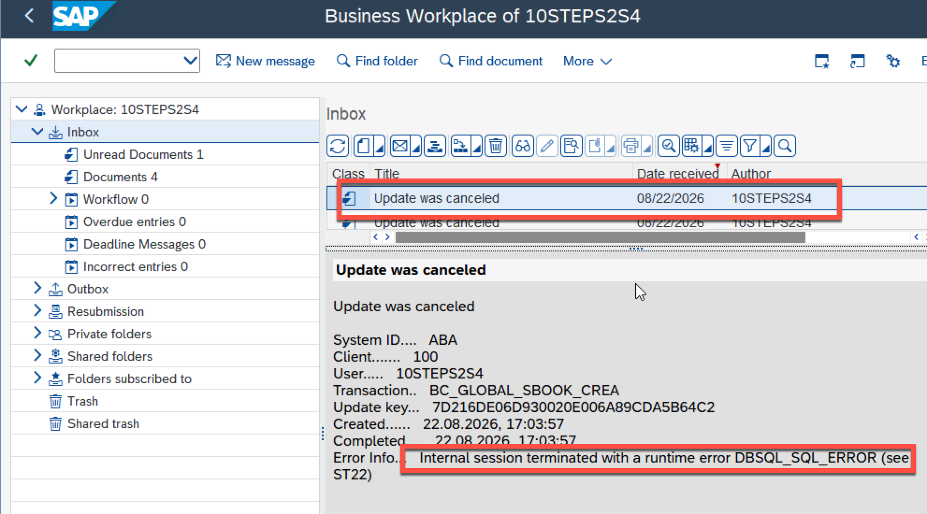  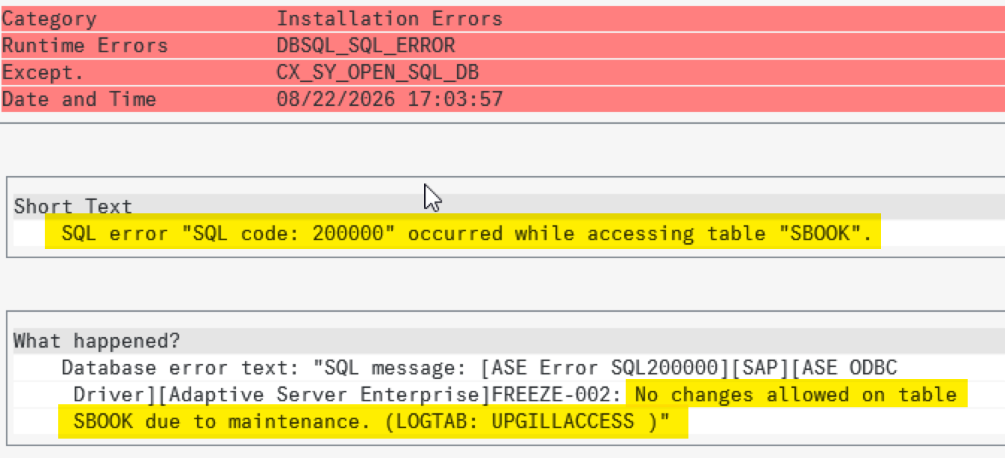  You can check the booking in the tcode BC_GLOBAL_SBOOK_DISP tcode  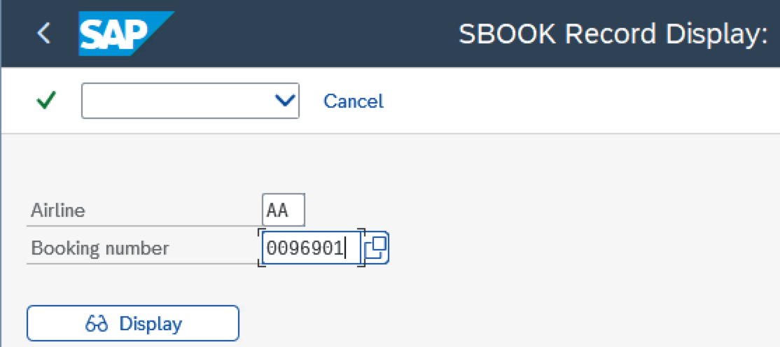  You would see that the transaction didn’t go through due to the trigger.  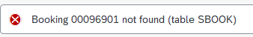
8 | See the behavior with the booking transaction with FREEZE_OFF | 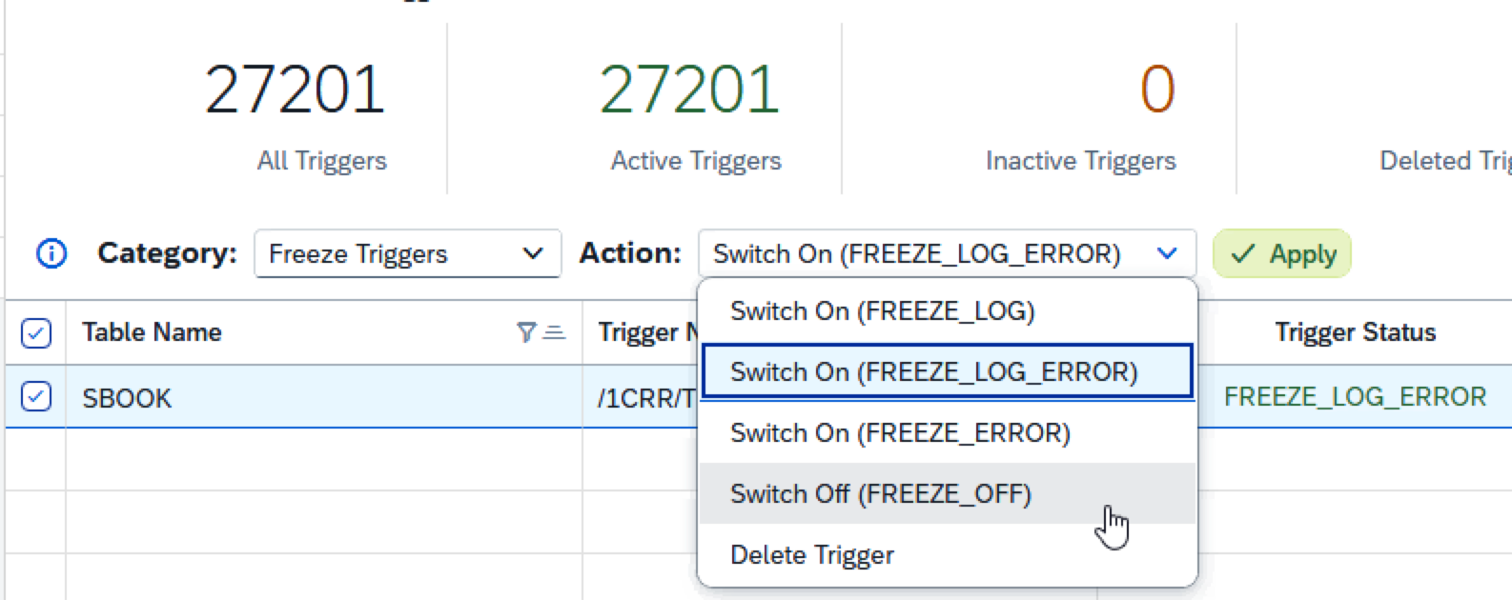

Note: you can do these actions en masse to a large number of tables.

Help documents
https://help.sap.com/docs/SLTOOLSET/b0d775c8a9fd47b985a5e66ddba31d33/53d7780f8f6c478c9ed12ae995ff8733.html?locale=en-US

www.sap.com.

